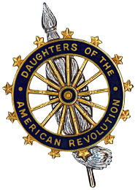

**NATIONAL SOCIETY DAUGHTERS OF THE AMERICAN REVOLUTION**

**AMERICAN INDIANS COMMITTEE**

Proclamation

**National American Indian Heritage Month**

**WHEREAS**, the history and culture of our great nation have been significantly influenced by

American Indians and indigenous peoples; and

**WHEREAS**, the contributions of American Indians have enhanced the freedom, prosperity, and

greatness of America today; and

**WHEREAS**, their customs and traditions are respected and celebrated as part of a rich legacy

throughout the United States; and

**WHEREAS**, Native American Awareness Week began in 1976 and recognition was expanded by

Congress and approved by President George Bush in August 1990, designating the month of November, as National American Indian Heritage Month; and

**WHEREAS**, in honor of National American Indian Heritage Month, community celebrations as

well as numerous cultural, artistic, educational, and historical activities have been planned;

**NOW THEREFORE,** I, Bruce Fraley, by virtue of the authority vested in me as Mayor of Berea,

Kentucky, do hereby proclaim November as the National American Indian Heritage Month, in Berea, Kentucky, and urge all our citizens to observe this month with appropriate programs, ceremonies, and activities.

**IN WITNESS WHEREOF**, I have set my hand and caused the Seal of the City of Berea to be affixed

this 14th day of November, the year of our Lord two thousand and twenty-four.

______________________________

Bruce Fraley, Mayor

City of Berea, Kentucky