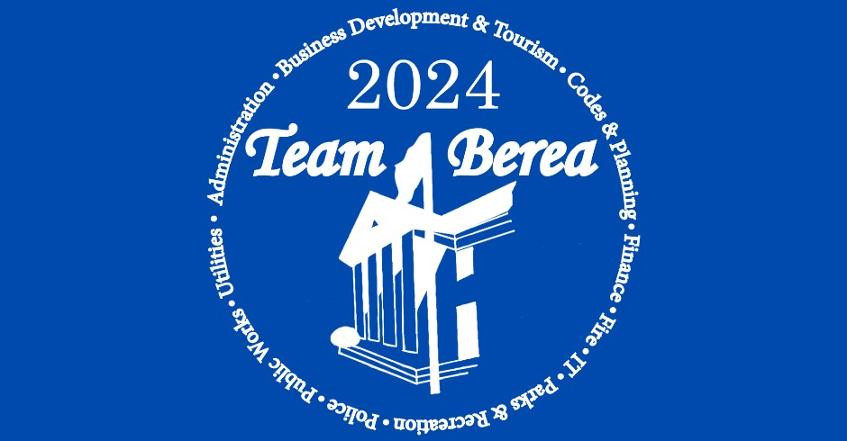

**PROCLAMATION**

**of the City of Berea**

**National Public Service Recognition Week**

**May 6 - 10, 2024**

**WHEREAS**, Americans are served every day by public servants at the federal, state, county, and city levels, who supply continuity to our society; and

**WHEREAS**, public employees serve to keep our city working by ensuring clean water, reliable power, public infrastructure, health and recreation, public safety, and proper management of public funds and resources, and more; and

**WHEREAS**, the efficiency of government relies on public employees, who provide services in the quality and quantity required and expected by the public; and

**WHEREAS**, the public employees of the City of Berea are committed to exhibiting the highest standards of professional excellence, creativity, skill, and customer service; and

**WHEREAS**, the City of Berea recognizes the generous contributions of time and talent by city employees and the importance of the services they render;

**NOW, THEREFORE**, I, Bruce Fraley, Mayor of the City of Berea, do hereby proclaim May 6 - 10, 2024 as Public Service Recognition Week in the City of Berea and call upon all citizens to recognize and express their appreciation for the important contributions of public service throughout the city.

___________________________________________

**Bruce Fraley, Mayor**

___________________

**Date**